Northumberland Cheese Company Cheese’s available on the rounds and in the Vending Huts from Hauxley Farm Dairy
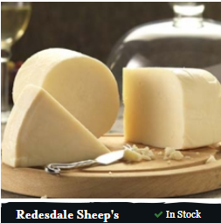
Redesdale Sheep’s
£6.59 / 150g
A sweet, subtle sheep's cheese. It has a rich, velvety texture, clean characteristic taste and refreshing tang. Those of you who hear 'sheep's milk' and are concerned that it will have the same strong character as a goat's cheese; try it. The subtle and enticing flavour will surprise you!

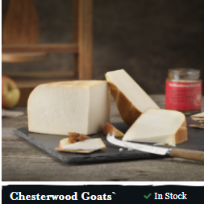
Chesterwood Goats
£6.39 / 150g
Made with milk from a single herd of goats in Yorkshire and lightly smoked over Oak wood chippings to produce a russet outer core and encase the sweet rich notes of the goats cheese whilst delivering a delicate natural smoky taste.

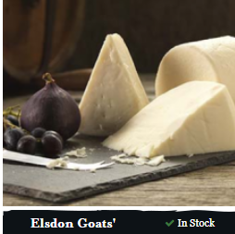
Elsdon Goats
£6.39 / 150g
Elsdon is made with goats' milk from a single herd in Yorkshire. It is hard-pressed, and it has a closed texture. It is a beautiful pure white colour, and it has a delicate flavour, with a refreshing tang as the end note.

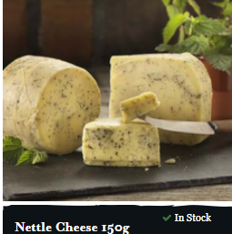
Nettle Cheese
£4.89 / 150g
The nettles bring a subtle but complex dimension to this cheese enhancing the rich and creamy qualities.

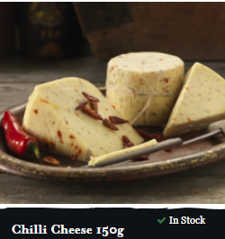
Chilli Cheese
£4.89 / 150g
Perfectly balanced, with the creaminess of Original cheese, and a flourish of chilli, this cheese has a building warmth which has a kick in the end.

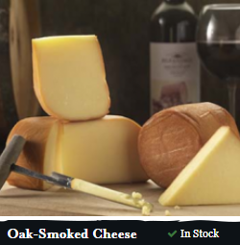
Oak Smoked Cheese
£4.99 / 150g
This cheese is cold smoked over oak wood chippings to develop a bronzed outer core and a beautifully smoky taste.

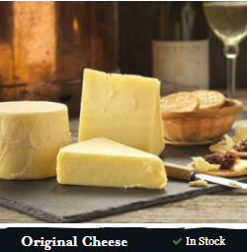
Original Cheese
£4.99 / 150g
Original is a mild handmade cows' milk cheese, which is extremely versatile in the kitchen. A cool, silky texture bursts into a rich, buttery flavour with a satisfying finish. Original is based on a Gouda recipe.

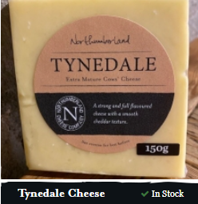
Tynedale Cheese
£3.99 / 150g
A strong and full flavoured cheese with a smooth cheddar texture.

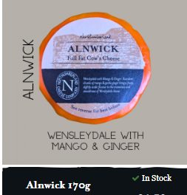
Alnwick
£5 / 170g
A waxed truckle. Succulent chunks of mango & gentle ginger bring a fruity, slightly acidic flavour to the creaminess and smoothness of Wensleydale cheese.

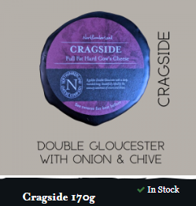
Cragside
£5 / 170g
A waxed Truckle. A golden Double Gloucester cheese with a deep round tang, beautifully lifted by the savoury sweetness of onion & chives.

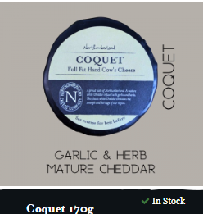
Coquet
£5 / 170g
A waxed Truckle. A mature white cheddar infused with garlic & herbs.

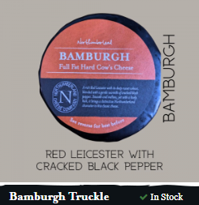
Bamburgh
£5 / 170g
Bamburgh Waxed Truckle - a Northumbrian take on Red Leicester with cracked black pepper.

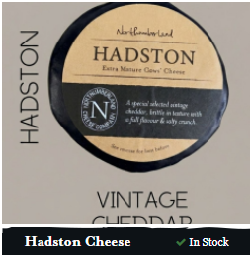
Hadston
£5 / 170g
A special selected vintage cheddar, brittle in texture with a full flavour & salty crunch.

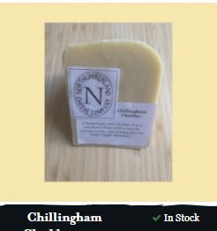
Chillingham
£6.60 / 300g
A handmade mild Cheddar it is a semi-hard cheese with a smooth, creamy texture and a tangy flavour with slight sharpness.

